**Academic English Guide**

Phase #2 – From March 26th to April 3rd.

**Student:** Carla Daniela Ruiz **Grade:** 10-11th. Grade

**English Level:** C1

**GENERAL INSTRUCTIONS**

* The assigned work will be divided into the four language areas that we exercise on a regular basis in class (Listening, Reading, Writing & Grammar). Every language area will have an assigned grade and a specific rubric for its revision.
* The objective is to exercise them throughout the week and deliver the final product to the latest on **April 3rd** by email to the following address:

[nivelmedio-ingleszacapa@colegioverbo.edu.gt](mailto:---------@colegioverbo.edu.gt)

* Save your document like this: **Student´s name_10th Grade_English Guide**
* This guide must be presented identified with name, grade and level the student belongs to.
* If necessary, insert text boxes in order to identify and fulfill your work.
* Remember to apply the appropriate use of grammar, spelling, punctuation and capitalization rules in each activity you do.

|  |  |
| --- | --- |
| **Contents** | **Christian Philosophy** |
| * Vocabulary Builder * Reading about “Biggest cities” * Article * Future tenses | * **Bible Principle:** Christian Character * **Bible verse:** Genesis 24:11 * **Value:** Loyalty |

**VOCABULARY AND LISTENING**

**Instructions:** Watch out the chart below, then search the definitions of the words in the internet and write them down.

|  |  |
| --- | --- |
| Widowed | Is a woman whose spouse has died, while a widower is a man whose spouse has died. |
| Childhood | Is the time for children to be in school and play, to grow strong and confident with the love and encouragement of their family and an extended community of caring adults. |
| Engagement | Is the relationship between two people who want to get married, and also the period of time between a marriage proposal and a marriage. |
| Marriage | The legally or formally recognized union of two people as partners in a personal relationship. |
| Spoiled | A person who is damaged by having been receiving everything they want. |
| Shrine | A place regarded as holy because of its associations with a divinity or a sacred person or relic, marked by a building or other construction. |
| Abduct | Take someone away illegally by force or deception, it could be called a kidnap too. |
| Measure | Ascertain the size, amount, or degree of something by using an instrument or device marked in standard units or by comparing it with an object of known size. |

**Instructions:** Choose 5 words from the list and do the following:

1. 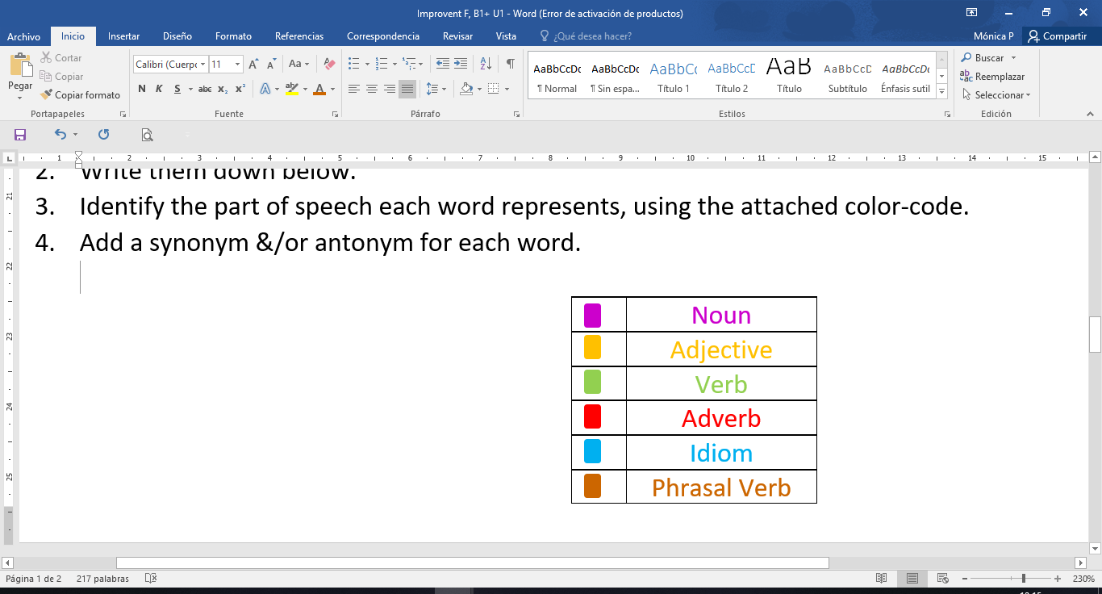List words in alphabetical order.
2. Identify the part of speech each word represents by using the attached color-code.
3. Add a synonym for each word.
4. Write one sentence applying each word.
5. **LIST WORDS IN ALPHABETICAL ORDER.**
6. Abduct
7. Childhood
8. Marriage
9. Measure
10. Widowed

**2. IDENTIFY THE PART OF SPEECH EACH WORD REPRESENTS BY USING THE ATTACHED COLOR-CODE.**

1. Abduct (Verb)
2. Childhood (Adjective)
3. Marriage (Adverb)
4. Measure (Noun)
5. Widowed (Noun)

**3. ADD A SYNONYM FOR EACH WORD.**

1. Abduct— kidnap
2. Childhood— infancia
3. Marriage—nuptials/wedding
4. Measure—size
5. Widowed—someone whose spousal died (i couldn’t find a synonym for this word :).)

**4. WRITE A SENTENCE APPLYING EACH WORD.**

1. The man abducted the little girl yesterday.
2. Childhood is the best part of growing up.
3. They haven’t think about a marriage, they are just living the moment.
4. For cooking a cake, you need to have the right measure for each ingredient.
5. My neighbor is a widow, her husband died last year.

|  |  |  |  |
| --- | --- | --- | --- |
| **Criteria** | **Evidence** | **No Evidence** | **Observations** |
| Lists the required words in alphabetical order. |  |  |  |
| Appropriately identifies the parts of speech by using the given color code. |  |  |  |
| Writes a synonym and antonym for each word. |  |  |  |
| Appropriately use of grammar and spelling. |  |  |  |
| Presents an example for each word through meaningful images. |  |  |  |
| **Total** | **/** | | |

**Vocabulary Checklist**

**READING**

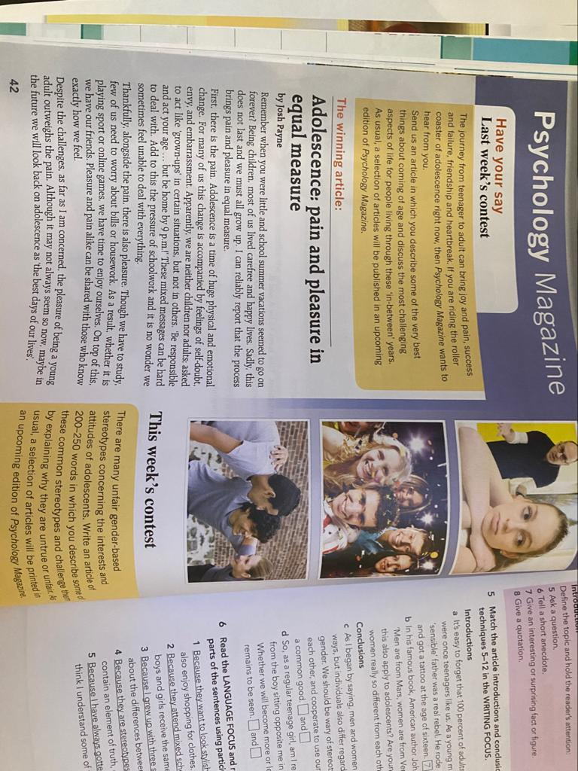**Instructions:** Read the text and complete the tips for writing an article with the words in the box.

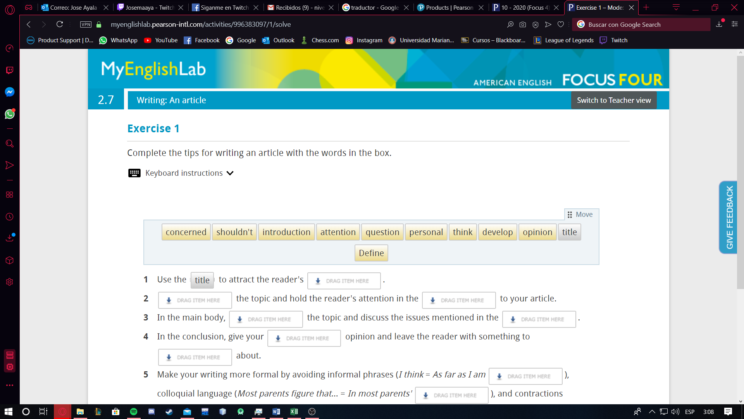

1. Use the ***TITLE*** to attract the reader's ____attention ____ .
2. ___Define___ the topic and hold the reader's attention in the __develop__ to your article.
3. In the main body, _____question_____ the topic and discuss the issues mentioned in the ______introduction______.
4. In the conclusion, give your ____personal____ opinion and leave the reader with something to _____think_____ about.
5. Make your writing more formal by avoiding informal phrases (I think = As far as I am ___concerned___), colloquial language (Most parents figure that… = In most parents' _____opinion_____), and contractions (_____shouldn´t_____= should not).

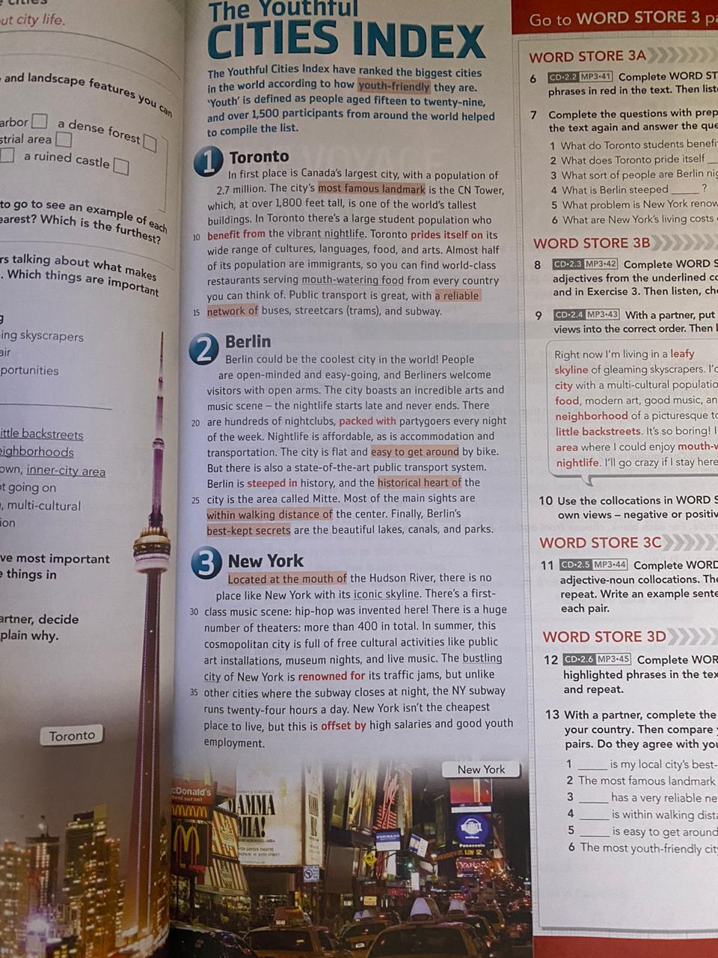

**Instructions:** Read the lecture “The Youthful Cities Index” and complete a graphic organizer with the biggest cities in the world (write the title in the middle example “TOP 5 BIGGEST CITIES)

* Include name
* Include population
* Include country

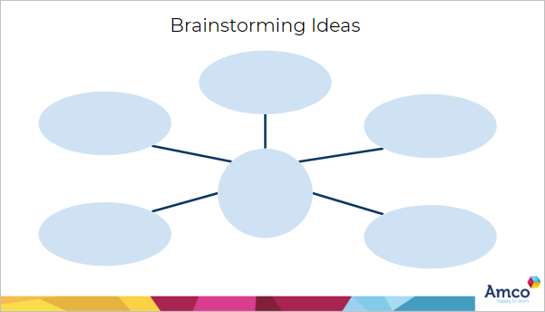

* New York
* 8.632 million
* United States
* Berlin
* 3.769 million
* Germany
* Toronto
* 2.7 million
* Canada

TOP 5 BIGGEST CITIES

**WRITING**

**Instructions:** Read the task below. Before you start writing, note down some ideas and plan your piece of writing. Then write an article. Include at least one sentence with a participle clause.  
  
Write an article of 140–190 words for your school's website. Describe the beginning of the friendship with your best friend and explain the role of friendship for young people as they grow up.

**THE BEST FRIENDSHIP**

It was my senior year and I was excited because of I had thought that that year was going to be my best year.

I met new people and I made new friends, but with one of them I connected so well, like we understood each other perfectly, and in just a few months we knew everything about each other, and now I think nobody knows me better than her.

But, is your friendship with your best friend the best?

For me, my best friend is always going to be the best of the entire world, because as I said, nobody knows me better than she does.

Valerie, my best friend, she knows every single thing about me, and what is just amazing is the way she knows when I am having a bad day, and when I am having a depressing day, she notices and she tries to make me feel better, asking me what is wrong and that if she can help in something. When I do not feel like telling her about what I feel, damn, she knows that, and she does not stop asking me why am I like that until I tell her why I am sad.

I do not like seen my best friend sad, or mad, or uncomfortable, because I feel like I have to do something because she is the happiest person I have ever met.

We have not had a fight, not really, we have just been mad two times, and the two of them she have be the one who got mad. I do not like expressing that I am mad or that I did not like something, not with her, she is the last person I would like to make feel bad because of my feelings.

She has helped me in my worst moments, in my ups and downs, and when I felt like giving up, she lifted me up.

I do not like hiding her things, and least when the things are really important, but, when I do that, it is because I do not want her to be disappointed of me. Last year, I did not tell her something I was passing through, and I did not know what to do in that time, because I did not have her to give me advices. When I told her, I was not in the situation anymore, but even that she knew I hided her that, she did not get mad, and helped me to get over the situation.

I do not know what would I do without her.

The story of my best friend and I shows that a real friendship is not the one that is perfect, It is just the one that understand and help each other every time it is necessary.

All of us need a person who trust in, and the teenagers need a best friend to tell and trust all the secrets that parents can not know.

* **Instructions:** Watch the following video in YouTube through this link: <https://youtu.be/SOCixRhRGDw>

Then create a graphic organizer with the most important information that is in the video

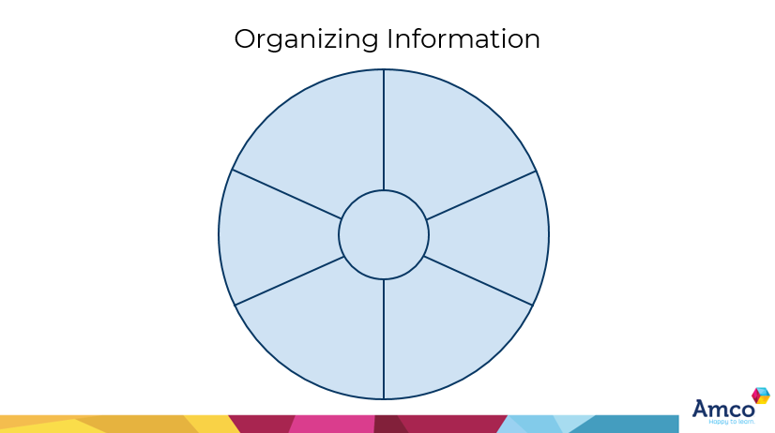

The space station use solar panels to provide energy

Astronauts are carried up into space by rockets.

Astronauts don´t take baths

In the space station there is less gravity

NASA

They do experimetns and excersise every day to keep their muscles in shape

To go home, they use space capsules

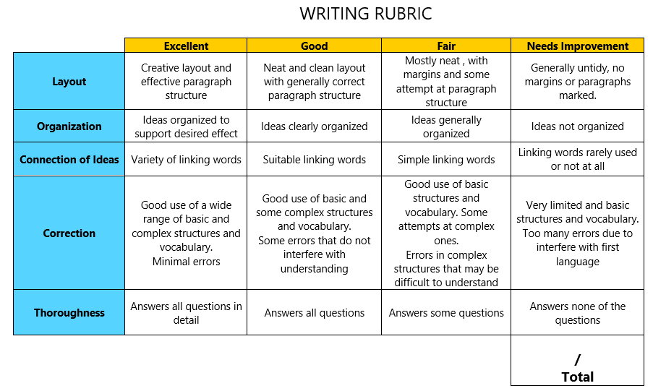

**GRAMMAR**

**Instructions:**

* Watch the following video in YouTube through this link to learn about future perfect: <https://www.youtube.com/watch?v=rcxytsa8CbI>
* Watch the following video in YouTube through this link to learn about future perfect progressive: <https://youtu.be/HPz_5NXh91E>
* Watch the following video in YouTube through this link to learn about future perfect progressive: <https://youtu.be/GxMy-7-IbGs>
* Then, create a comparative chart between the three uses including, rules/use, structures and examples

|  |  |  |  |
| --- | --- | --- | --- |
| INCLUDING | FUTURE PROGRESSIVE | FUTURE PERFECT | FUTURE PERFECT PROGRESSIVE |
| RULES/USE:  STRUCTURES:  +  -  ?  EXAMPLES  +  +  -  -  ?  ? | **Future Progressive**  1.Actions that will be happening at a certain time in the future.  2.Actions which will be interrupted by another one.  1.Subject + will + be + verb in present participle  2.Subject + will not + be + verb in present participle  3.Will + subject + be + verb in present participle  1.julio will be studying when he get his boks.  2.you will be loving Chinese food  1.He will not be graduating next year.  2.Skinny will not be barking noisily when we arrive.  1.will she be singing when we arrive?  2.will carry be loving the cake while she will eat? | **Future Perfect Progressive**  It shows that an action will continue up until certain period of time or event in the future.  1.Subject + will + have been + past participle.  2.Subject + won´t + have been + past participle.  3.Will + subject + have been + verb in present participle.  1.I will have been studying college by the time my dad let me have my own apartament.  2.Your dog will have been dying of hunger by the time u feed it.  1. I won´t have been studying college by the time my dad let me have my own apartament.  2. your dog won´t have been dying by the time u feed it.  1.will I have been studying college by the time I have my own house?  2.will your dog have been dying till u feed it? | **Future Perfect**  1.Actions that finished before another action.  2.Something that still happening in the future.  1.Subject + will + have + past participle verb  2.Subject + will not + have + past participle verb  3.Will + subject + have + past participle  1.They will have bought a new house.  2. I will have known that topic.  1.I wont have seen that movie  2.she wont have gone to the house yet.  1.Will I have finished the repot?  2.Will you have done the homework? |

